Feed motor torque prediction

Owen Lu

Electroimpact Inc.

owenl@electroimpact.com

*Abstract*—One of the added benefits of the servo creel is that the inertia of the spool should be unseen by the feed motor. As a result, the torque variation is significantly reduced and behaves in a predictable pattern. This paper investigates how torque variation can be predicted and used to aid control efforts at the business end.

# Introduction

The experimental setup uses the same apparatus from servo creel testing. This time data is recorded from the feed motor as opposed to the spindle motor.

The key data are listed:

1. Velocity command
2. Actual velocity
3. Motor torque

In a simplified dynamic model of the system, there are only a few main considerations that affect motor torque. The dancer spring tension, dancer mass and friction are the main elements creating opposing torque to the motor that can vary. In this test, a constant velocity with a superimposed sinusoidal velocity was used to generate data to build a simple model to predict torque variation at the feed motor side.

# Theory

Although spring tension and dancer acceleration are varying factors in the torque requirements, the characteristics of the servo control loop there is a direct linear mapping of commanded velocity to steady-state dancer displacement. This allows for easy prediction of dancer position and acceleration. One problem with this simplification is that the new control algorithm has two distinct behaviors that trigger based on dancer travel. Thus, at high speeds, there will inherently be error

To predict the steady state displacement there are two equations which depend on the velocity command (low or high speed). Equation 1 describes the displacement at low speed, and Equation 2 at high speed.

|  |  |  |
| --- | --- | --- |
|  |  | () |
|  |  | () |

The condition at which the operational mode switches is approximated in Equation 3.

|  |  |  |
| --- | --- | --- |
|  |  | () |

Thus, the threshold which separates what is colloquially called low or high speed is shown in Equation 4.

|  |  |  |
| --- | --- | --- |
|  |  | () |

This forms a piecewise linear function of steady-state displacement and feeds velocity. The threshold in the current control system is given as

The parameters used in this test are given below:

$$K_{e}=17.5rads^{-1}$$

$$x_{t}=2in=0.0508m$$

$$x_{r}=0.1in=0.00254m$$

$$v_{threshold}=0.845ms^{-1}=1995ipm$$

Note that this threshold velocity calculated so that adding material which at most can be done at 2000ipm would see a low control gain using more dancer stroke. This is important since for more aggressive accelerations a reduction in gain proportionally reduces motor torque at the cost of dancer stroke.

Since the spring has a preload and a stiffness constant the torque from the dancer displacement is given in Equation 5.

|  |  |  |
| --- | --- | --- |
|  |  | () |

The dancer acceleration can also be added to produce the overall torque. If we view the problem a curve fitting problem then torque $T$ can be written in a linear 2 variable expression.

|  |  |  |
| --- | --- | --- |
|  |  | () |

Note that due to the tension control system, there should be two expressions for $T$, one for low speed and another for high speed.

# Procedure

Below are the basic steps used to collect data.

1. Feed tow through the dancer system
2. Calibrate dancer and diameter sensors
3. Run tension control algorithm
4. Run 2000ipm feed with superimposed 1000ipm sinusoidal velocity at 10 $rads^{-1}$
5. Record velocity, actual velocity and motor torque of the feed motor

# Results

As expected the torque requirement from the feed motor was relatively low. Even with the superimposed sinusoidal velocity which had a maximum of approximately 0.5G acceleration, torque stayed within a 0.17Nm band. The feed motor accelerates tow with no gearbox (direct drive) which means that load torque is not scaled. In the current system a 7:1 reducer is used on a 2000W motor. This motor has an instantaneous stall torque of approximately 9Nm. Using the data to approximate what the feed motor would experience in the worst case scenario results in 1.7Nm which is approximately 20% of instantaneous stall torque.

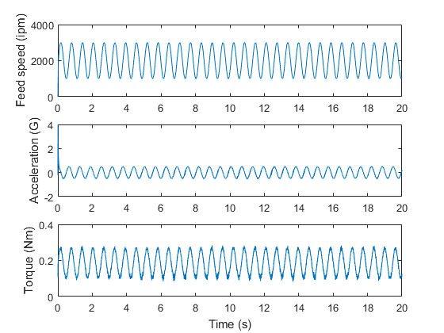

Figure – (top) Measured feed speed converted to ipm; (middle) calculated dancer acceleration; (bottom) measured torque in Nm

Plotting torque versus the velocity and acceleration shows an elliptical plot with points approximately on a plane. This is exactly expected.

Using the curve fitting tool we can find constants in Equation 6. In Figure 2, the planar fit is shown.

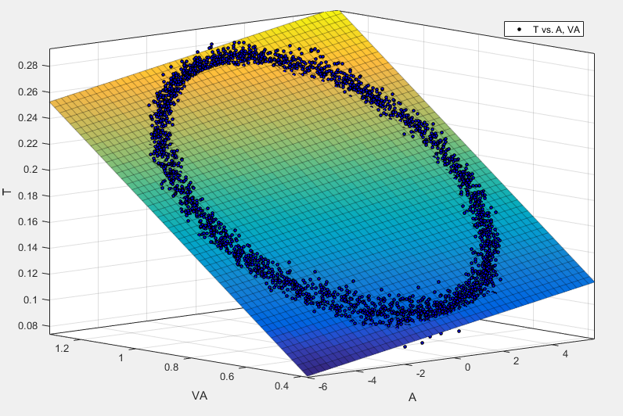

Figure - Planar curve fit on torque plot

Following are the constants with their 95% confidence intervals.

$$k_{0}=0.02527 \left(0.02471,0.02583\right)$$

$$k_{1}=0.1894 \left(0.1887,0.190\right)$$

$$k_{2}=0.003594 \left(0.003538,0.00365\right)$$

$$RMSE=0.006363Nm$$

As it turns out even though the torque expression should be piecewise, the RMSE is sufficiently small.

# Suggested Implementation

After the machine is built, a calibration routine to calculate the torque equation constants in Equation 6 can be made. This would require each lane to be fed individually, with a few sinusoidal velocity cycles. A simple way to calculate the constants uses an assumed overdetermined system. We can use the data to create matrices $A,T$ and solve for linear constants in .

|  |  |  |
| --- | --- | --- |
|  |  | () |
|  |  | () |
|  |  | () |

Thus, the overdetermined linear system can be written as in Equation 11.

|  |  |  |
| --- | --- | --- |
|  |  | () |
|  |  | () |

Another issue is the estimation of dancer acceleration. Currently, the MATLAB implementation uses 4th order finite difference approximation constants for equally spaced data.

# Conclusion

From experiment, it has been shown that using a simple linear approximation that torque can be estimated with reasonably small error (3% RMSE). Thus, in practice, a calibration routine can be written to predict torque from each lane so that resultant adjustments to feed motor torque can be added. From the data however, the maximum torque measured which occurred at 3000ipm only generated a motor torque of approximately 0.3Nm. In practice the feed motor does not advance the tow to full speed, thus for this application the motor is oversized. For intermittent operation, this motor can provide roughly more than 10 times the torque required. This is expected since no changes were made to the business end and 16 servo motors have been added to handle the inertia of the spools.